
Technical Architecture Overview

 Release Notes Feature — Technical Architecture

 Read This First — One-Time Build vs. ♾ Ongoing Use
Everything below is a one-time engineering build. Once shipped, publishing a new release note is a permanent, zero-code, self-service activity — Admins/PMs never need engineering again for routine content.

🛠 One-Time (this document covers this) | 🔁 Ongoing (every release, forever)
Who | Engineering
What | DB, stored procedures, API, React components below
Deploy needed? | Yes, once
> 📎 Full boundary table + "when IS a developer needed again" → page Jul 1, 2024 in
release- notes- architecture. drawio .
 Table of Contents
- Purpose
- Tech Stack Context
- High-Level Architecture
- Frontend Architecture
- Backend Architecture
- Database Schema
- Data Flow Summary
- Security Notes
- Extension Points
- Known v1 Limitations


Purpose

A DB-driven "What's New" system. Content is authored entirely through an Admin Panel CRUD screen.
> 💡 Key principle: no code change or deploy is ever required to publish a new release note.
Surfaced in three places: a Docs page tab, a header bell icon with unread badge, and a one-time popup modal. Per-user read tracking powers all three.


Tech Stack Context

Layer | Technology
🎨 Frontend | React 18, MUI 5, React Router 6, axios, react-toastify
⚙ Backend | Node.js, Express, mssql driver
🗄 Database | SQL Server (MSSQL)
🔐 Auth | JWT via httpOnly cookie, existing auth middleware (reused as-is)

🏗 3. High-Level Architecture
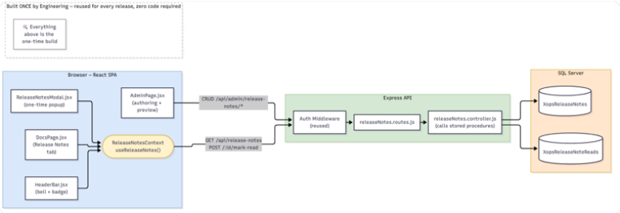

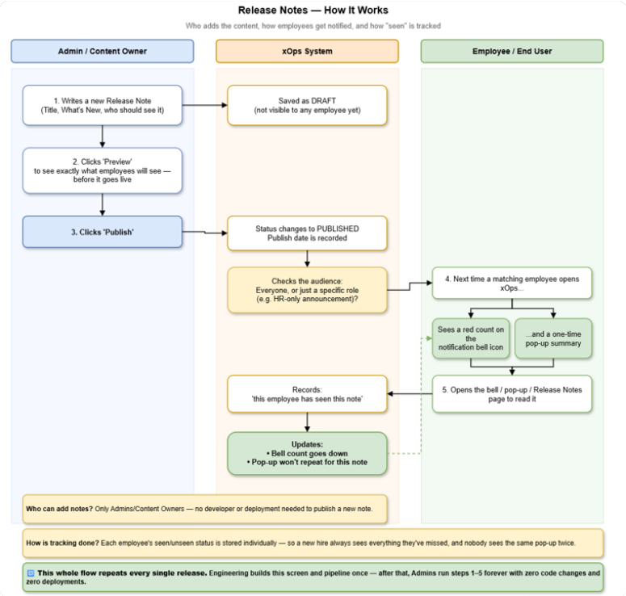

📎 Full component/DB diagrams:
release-notes-architecture.drawio
(ERD).
otes-db-schema.drawio

🖥 4. Frontend Architecture

  - New/changed files
(pages 1–6),

release-n
File | Status | Responsibility
  src/context/Relea seNotesContext. j s x | new | Single source of truth: fetches GET  /api/release-notes once per session, derives unreadCount , exposes markAsRead(id)

  src/components/La yout/HeaderBar. j s x | edit |   Activates the existing (inert) NotificationsIco n — Badge + dropdown Menu , consumes the context
src/Pages/DocsPag  e. j sx | edit | Dynamic "Release Notes" section — fetches via context, renders via the existing SECTION_RENDERER  S dispatcher
src/docs/docsData  . j s | edit | Retire the static commented-out release- notes stub once the dynamic tab is live
src/Component/Rel easeNotesModal. j s x | new | One-time-per-session popup, mirrors HRReminderNotice. j sx 's "fetch → show  → dismiss → mark  done" pattern
src/Pages/AdminPa  ge. j sx | edit | New "Release Notes" tab: table + Add/Edit dialog + Edit/Preview toggle + block builder
src/App. j sx | edit | Mounts ReleaseNotesProvi der (wrapping  <Layout> ) and  <ReleaseNotesModa  l /> alongside


<HRReminderNotice
/>

  - — shape
ReleaseNotesContext

1
2
3
// Returned by useReleaseNotes()
{
notes,
// array of published, role-filtered notes (admin
notes use a separate admin-only fetch)
4
5
6
7
8
unreadNotes, unreadCount, loading, error, markAsRead,
// notes. filter(n => ! n. isRead)
// unreadNotes. length
// (id) => optimistic local update + POST
/api/release-notes/: id/mark-read
9
10
refresh,
// manual refetch trigger
}
Why a Context and not 3 independent useEffect fetches: ,
, and DocsPage all mount on nearly every route. Independent fetches would mean 3x the network calls per page load. The Provider fetches once (on mount, post-auth) and all three subscribe to the same state — dismissing in the modal instantly updates the bell badge too.
HeaderBar
ReleaseNotesModal

  - Content rendering reuse
Release note bodies are stored as — an array of blocks matching the **same
ContentJson
shape** already uses:
docsData. j s

1
2
3
4
5
6
ContentJson = [
{ type: ' text' ,
{ type: ' list' ,
heading, body },
heading, items: [ ] },
{ type: ' callout' , variant: ' info' | ' warning' | ' tip' , body },
{ type: ' cards' ,
heading, cards: [ { icon, title, description }] },
]

Both DocsPage. j sx and ReleaseNotesModal. j sx render these through the **existing**
SECTION_RENDERERS dispatcher ( DocsPage. j sx ) — no new rendering code needed. v1
cards
docsData

admin block builder only exposes text / list / callout /
steps
table
(the other

types —
/
/ flow / iconList / exportPanel — are intentionally out of scope

for v1 but the renderer already supports them if a future block type is added).


  - Admin authoring UX

New "Release Notes" tab in AdminPage. j sx , following the existing HR Reminders tab pattern
Dialog
toast. success/warn/error

(table +
+ handleSave* / handleDelete* + ).

The Add/Edit dialog has an **Edit / Preview** Tabs toggle — Preview mode renders the in-progress (unsaved) form state through the same SECTION_RENDERERS dispatcher, so the

author sees an exact live preview before hitting Save/Publish — pure client-side render, no round-trip.


Backend Architecture
  - New files

File | Responsibility
routes/releaseNotes. routes  . j s | Registers endpoints, mounted in app. j s the same way other route modules are
controllers/releaseNotes. c  ontroller. j s | Thin layer — calls stored procedures via mssql , no business logic/SQL inline
scripts/migration- release-  notes. sql | Schema (tables + indexes), idempotent
scripts/rollback- release-  notes. sql | Reverses the migration
scripts/sp_ReleaseNotes_*.  sql (8 files) | One stored procedure per file, matching the existing sp_UpsertAdminUser. sql  convention
scripts/performance- check-  release- notes. sql | Seed data + index-usage verification queries


  - Why stored procedures (not inline SQL)
Every data operation goes through a ,
stored procedure ( sp_ReleaseNotes_GetPublished
GetAllForAdmin , Add , Update , TogglePublish ,
MarkAsRead

— no string-built or inline SQL in JS. This matches the codebase's existing admin-module convention
GetUnreadCount , ,
Delete ). The controller only does
pool. request() . input(. . . ) . execute(' sp_ReleaseNotes_X' )
sp_AddDelegatedAccess

(
sp_UpsertAdminUser
,
) and keeps query plans stable/reusable

(parameter sniffing is predictable, and a DBA can tune/review procedures independently of app deploys).


  - Controller → stored procedure map

Controller function | Stored procedure | HTTP route
getPublishedRelea  seNotes | sp_ReleaseNotes_G  etPublished | GET /api/release-  notes
getUnreadCount | sp_ReleaseNotes_G  etUnreadCount | GET /api/release-  notes/unread-  count
markAsRead | sp_ReleaseNotes_M  arkAsRead | POST  /api/release-  notes/: id/mark-  read
getAllForAdmin | sp_ReleaseNotes_G  etAllForAdmin | GET  /api/admin/releas  e- notes
addReleaseNote |   sp_ReleaseNotes_A  dd | POST  /api/admin/releas  e- notes/add
updateReleaseNot  e | sp_ReleaseNotes_U  pdate | PUT  /api/admin/releas  e- notes/: id
togglePublish | sp_ReleaseNotes_T  ogglePublish | PATCH  /api/admin/releas  e-  notes/: id/toggle-  publish
deleteReleaseNot  e | sp_ReleaseNotes_D  elete | DELETE  /api/admin/releas  e- notes/: id

Role/audience filtering ( VisibleToRoles ) happens **inside the stored procedure**
( sp_ReleaseNotes_GetPublished / GetUnreadCount ), not in JS and not just hidden client-side — the API itself never returns role-restricted content to the wrong audience.


  - vs
/api/release- notes/*
/api/admin/release- notes/*

Route | Access
/api/release- notes/* | any authenticated user; auth middleware only.
/api/admin/release- notes/* | additionally requires the admin-role check already used by  admin. routes. j s .

🗄 6. Database Schema
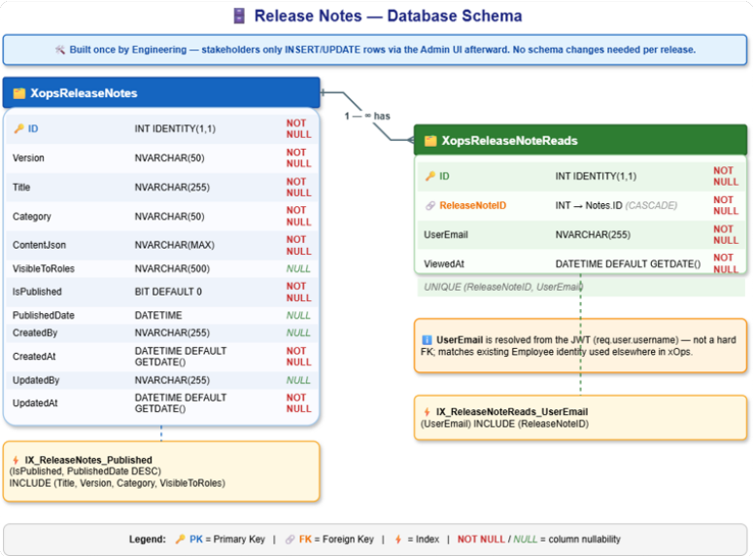

> 🔑 Indexes
IX_ReleaseNotes_Published (IsPublished, PublishedDate DESC) INCLUDE (Title, Version, Category, VisibleToRoles) — serves the main list query as a pure index seek.
IX_ReleaseNoteReads_UserEmail (UserEmail) INCLUDE (ReleaseNoteID)
— serves the unread-count lookup (the UNIQUE constraint's leading column is
ReleaseNoteID , so it can't serve this direction).
> ⚠ Note: UserEmail is not a hard FK to an employee table — it's resolved from the JWT ( req. user. username ) at request time, matching how user identity is referenced
elsewhere in xOps.

🔄 7. Data Flow Summary

1 flowchart LR
2
A[ " ✍ Admin Input" ] - - > B[ " Client Validation" ] - - > C[ " Serialize →
ContentJson" ] - - > D[ " POST/PUT
3 /api/admin/release- notes" ] - - > E[ " sp_ReleaseNotes_Add/Update" ]
Write path (Admin): form input → client validation → serialize blocks to →
→ controller validates + resolves role string →
ContentJson
POST/PUT /api/admin/release- notes
sp_ReleaseNotes_Add / Update → row in
.
XopsReleaseNotes

- flowchart LR
- F[ " ReleaseNotesProvider mounts" ] - - > G[ " GET /api/release- notes" ] - -
> H[ " sp_ReleaseNotes_GetPublished
- (role- filtered + isRead j oin) " ] - - > I[ " SECTION_RENDERERS
- (Docs / Bell / Popup) " ]
Read path (User): ReleaseNotesProvider mounts → GET /api/release- notes → sp_ReleaseNotes_GetPublished (role-filtered, LEFT JOIN XopsReleaseNoteReads for isRead ) → rendered via SECTION_RENDERERS in Docs page / bell dropdown / popup.

1 flowchart LR
2
J[ " User opens/dismisses note" ] - - > K[ " markAsRead(id)
- (optimistic update) " ] - - > L[ " POST /: id/mark- read" ] - - >
M[ " sp_ReleaseNotes_MarkAsRead
- (idempotent upsert) " ]

Tracking path: reflected in the next
GetPublished
/ GetUnreadCount call.


Security Notes (dev-relevant)
All SQL access is parameterized via stored procedure concatenated.

— never string-
@params

the fixed component set — never
ContentJson is rendered via
dangerouslySetInnerHTML
SECTION_RENDERERS
of raw admin input, so no stored-XSS surface even though
content is admin-authored.
- Auth/authorization is **fully reused** from the existing middleware — no new auth mechanism was introduced.


Extension Points (for future developers)
- New block type (e.g. table ): add a case to the admin block-builder form; the renderer

( SECTION_RENDERERS ) likely already supports it from the
docsData
DocsPage. j sx first.
- New audience granularity (e.g. per-department instead of per-role):
system — check

is a

simple comma-separated string matched via in the stored procedures —
VisibleToRoles
CHARINDEX
swapping to a join table would require a new migration + updating
sp_ReleaseNotes_GetPublished
GetUnreadCount

untouched).
/
only (controller/frontend

- Real-time push (no polling/refresh needed): not implemented in v1 —
refresh()
context is manual/interval-based today; a websocket/SignalR push would plug into without touching the DB layer.
ReleaseNotesContext
on the


Known v1 Limitations
- No pagination on sp_ReleaseNotes_GetAllForAdmin — fine at current volume (admin-authored, low write rate); add TOP N /paging if the list grows large.
- Popup "show once" guard is session-based (client) backed by server-side read state — not a
hard real-time cross-device sync (acceptable per product decision, see PM flow diagram).

Maintained alongside release-notes-architecture.drawio · xOps Engineering

